Professor James E. Lloyd (Jim)
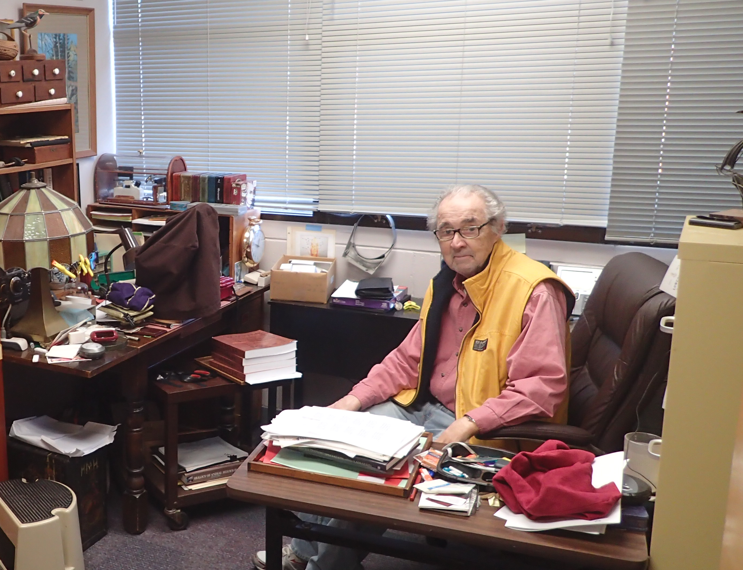

Professor James E. Lloyd, a gifted educator and scientist, and a member of the emeritus faculty of the University of Florida, Entomology and Nematology Department, passed away about two weeks ago. He is pictured in his office at the Department seated next to a stack of books that I noticed as I took this photograph. These books were part of the first printing of 40 copies of A Naturalist’s Long Walk Among Shadows: of North American Photuris he completed in September 2017 to describe his life’s work. He handed me a precious copy and also placed his masterpiece online (http://entnemdept. ufl.edu/lloyd/firefly/) for all to study and enjoy. It is packed with historic photographs and descriptions of the firefly species he described and dedicated to special people in his life, such as his beloved wife, Dorothy, and the original or naturalized Floridians, Marc Branham, Tom Walker, John Sivinski, and Sandy Fairchild. At the beginning of his book, he acknowledged all who helped him during his Long Walk.
Professor Lloyd was one of the elite biologists of his time, being a friend and respected colleague of E. O. Wilson, Ernst Myer, Thomas Eisner, Archie Carr and many other notable scholars who frequently visited him in Gainesville. I was thrilled and somewhat intimidated when Jim invited me to one of their private receptions. At the time, striving to be a behavioral ecologist, I organized a symposium, Sociobiology of Sex, at the 1978 meeting of the Entomological Society of America, Southeastern Branch and invited Jim to be a presenter. Everyone was reading E. O. Wilson’s Sociobiology that was published in 1975. The symposium papers were published in the Florida Entomologist and I have a photograph of Jim down on his elbows and knees beside the highway to Cedar Key taking the reprint cover photograph of lubber grasshoppers. Jim enjoyed our symposium, so together we initiated a series on behavioral ecology that he organized and led for six years at annual meetings of the Florida Entomological Society (https://journals.flvc.org/flaent/issue/view/2758).
Jim was an inspiring educator both in and outside of the classroom. I recall passing the window of his classroom and being captivated by the student’s enthusiasm in conducting exercises on firefly communication and related insect behavior. When Patch Adams, the eccentric physician, heard that Jim could communicate with fireflies he talked him into attending one of his unconventional gatherings as an honored guest. The gatherings were depicted in the 1998 movie about Patch Adams starring Robin Williams. Every summer, Jim drove his camper up the East Coast to New York, stopping along the way to collect fireflies and share his stories about their behavior, featuring the “femme fatale” Photuris species. Carol, my wife, and I were honored for Jim to include a stop in Annapolis, Maryland to visit us on his annual migrations. One year, he arrived when we were having a neighborhood party on our deck overlooking Saltworks Creek. He began talking about fireflies and soon everyone was gathered in a circle around him, enthralled with his stories and completely oblivious to the setting and the food! Jim was naturally charismatic and totally consumed by his entomological activities. This made him seem reclusive at times but he was loved by all who knew him.

Norm Leppla

